RIFGC Environmental / Education Day 2023
Wednesday March 1
Welcome to our joint Environmental/Education Day
Bring your own lunch. Coffee, tea and water will be available.
We will have Environmental Tables filled with exciting information.
Take home bags with samples, hints, ideas and a solution for the tick problem in your yard

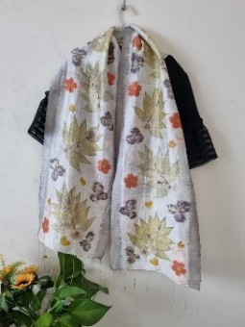 9.00 am- 10.00am
Dying Silk Scarves
Textile Designer and Fiber Artist Robyn Borges will demonstrate how to dye fabrics with natural dyes.
This demo will also include the creative process of printing silk scarves with native leaves and flowers.

10.15 am – 11.15am
Prudence Memorial Park – A Green Burial Cemetery
You may have heard of an environmentally friendly alternative to the traditional protocols by
which we typically honor the lives of loved ones and lay them to rest.
Learn about this low carbon alternative and visit the Memorial Park with its beautiful wildflower gardens

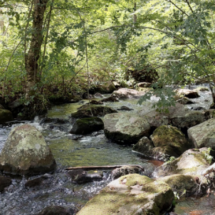 11.30 am – 12.30pm
The RI Nature Conservancy will present “Explore the Places We Protect”
What a wonderful gem we have here in Rhode Island! We will be made aware of the many preserves we have. The decision making process
That goes into the making of a preserve and the sights within the state that are open to the public.
12.45 pm – 1.45pm
Floral Easter Basket
It’s almost that time of year! A floral demonstration on how to make an easy Easter Basket.
You a welcome to bring all of your supplies and make a basket while the Instructor teaches.
- Between presentations our Environmental Chair will talk to us about alternatives to harmful chemicals.
- Please attend and let us know if you will be there, this way we know how many gift bags to make up.

