The RI Federation of
Garden Clubs, Inc.
Newsletter
Winter 2020 No.3
President Deb Ort, Editor

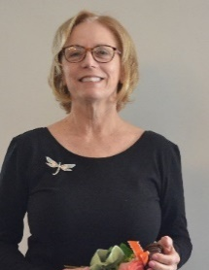
Winter

I love how winter provides opportunities to move through natural spaces in unique and different ways compared to the same landscape during the growing seasons. Freezing temperatures mean you can literally walk on water. Tromp off into woods somewhere and enjoy the fact that there are no bugs. I love the snow and cross-country skiing. It is so peaceful.
On October 28 and 29, I attended the New England Garden Club Annual Meeting in Woodstock, VT. Each New England State President was allowed 3 minutes to talk about their state. It was very hard to get all that we do in Rhode Island expressed in 3 minutes. I spoke quickly telling of our great clubs, speakers, community plantings, our 90th Anniversary in 2020, and as much as my time allowed.
I have been very lucky to have such wonderful Committees and Chairs that I have been working with during my first 9 month. Thank you all so much. Vera Bowen arranged for a wonderful, well attended Education Day at the Roger Williams Casino. John Campanini of the Rhode Island Tree Council gave an informative talk on invasive pest spreading

throughout the mid-Atlantic. A potential introduction into Rhode Island poses a significant threat to RI’s agriculture, landscape and nursery industry. (More information on page 10.)
Blakely Szosz designed a beautiful, sizeable outdoor arrangement using mostly outdoor materials. Lynn Merrell designed several unique holiday designs, and our event was concluded with an informative walk outdoors.
In nine months, we have had monthly meetings with refreshments prepared by volunteering garden clubs. A round table discussions on Membership was informative. Polo was again enjoyed; Penny Pines was established; Habitat for Humanity had a planting in Bristol; the Design Study Group offered four design classes, and our Holiday Luncheon at the Sakonnet Point Club was well attended.
We look forward to the 2020 Flower Show; the Life Member Group Luncheon, the Annual Meeting, Awards Luncheon and our 90th Year Anniversary.
These are a few of my favorite things from 2019.
Again, thank you all very much for making this a wonderful year. A president is only as successful as the members who work together for the good of all members.
Sincerely, Deb Ort, President
Plant Rhode Island, Remember Your Roots

AWARDS

The awards program affords National Garden Clubs, Inc., the New England Region, and the Rhode Island Federation of Garden Clubs, Inc. an opportunity to express their support and appreciation for all the club projects that were completed or were in progress during the past year. By honoring our clubs, we hope to promote growth and stimulate our members to plan their programs and activities for the coming year in accordance with the objectives of our organization.
RIFGC State Awards Chairmen:
Cheryl Celeste, 90 Salem Avenue, Cranston, RI 02920 Phone: 401-943-5420 and Kathleen Damiani, 137 Park Forest Road, Cranston, RI 02920 Phone: 401-323-5407
Email: gardenclubckawards@gmail.com
Please Note: Awards submissions must be sent to RI State Chairman, by February 15, 2020.

RIFGC Community Project Award
Do you have a community project that you would like to start and feel that you are unable to do so due to lack of funds? The RIFGC, in an effort to “give-back” to the clubs, has $2000.00 available to help with these projects. Clubs receive a maximum of $500. No club can win two years in a row. This award will not be judged!
Please send your application to President, Deb Ort at debcurtort@gmail.com.

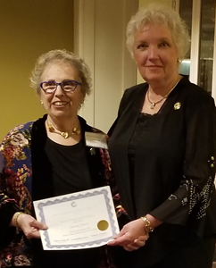
Annette Jarvis, at New England Garden Club Annual Meeting receiving the NEGC Award of Honor.
Suzanne Bushnell, NEGC Director, presided

NEGC Awards were given out at the NEGC Annual Meeting in October 2019.

NEGC Award bestowed the Yearbook Award for Club with 46-69 members FIRST PLACE Winner: Western Cranston Garden Club (Award presented at the 2019s Holiday Luncheon)
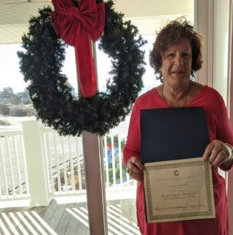

Awards below will be awarded at the January Meeting.
NEGC Award bestowed the Yearbook Award for Club with 30-44 members FIRST PLACE Winner: Cindy-Wood Garden Club
NEGC Award bestowed the Jeanne-Marie Parkes Award 2018-2019 to The Bristol Garden Club. (For creating an educational exhibit that can be displayed at a flower show, library, or other public building to encourage awareness of our environmental problems.)
NEGC Award bestowed the Mildred Black Pettit Award to the RI Federation of Garden Clubs, Inc
(To the NE State Garden Club with the largest percentage increase in new members.)

$25.00 $50.00 will be awarded to the club presenting the most outstanding Arbor Day program. An additional $75 gift, donated by Elizabeth McCaffrey, past president of RIFGC, may be awarded.
Application must include description, pictures, and publicity. For more information please contact our award’s chairs.

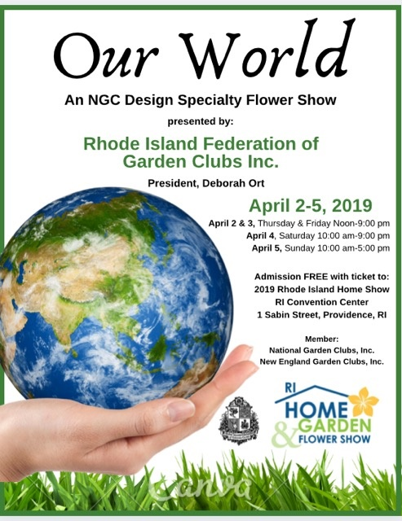

LET’S PLANT A TREE
by Aileen Fisher

It’s time to plant a tree, a tree.
What shall it be? What shall it be?
Let’s plant a pine—we can’t go wrong:
a pine is green the whole year long.
Let’s plant a maple—more than one,
to shade us from the summer sun.
Let’s plant a cherry—you know why:
there’s nothing like a cherry pie!
Let’s plant an elm, the tree of grace,
where robins find a nesting place.
Let’s plant an apple—not too small,
with flowers in spring and fruit in fall.
Let’s plant a fir—so it can be
a lighted outdoor Christmas tree.
Let’s plant a birch, an oak, a beech,
there’s something extra-nice in each…
in winter, summer, spring or fall.
Let’s plant a…
why not plant them ALL?

Calendar
January 24, 2020
RIFGC Board Meeting at Roger Williams
Park Casino 1000 Elmwood Ave, Providence, RI
9:30am refreshments, 10:00am Meeting begins

February 27, 2020

RIFGC Board Meeting at Roger Williams

Park Casino 1000 Elmwood Ave., Providence, RI 9:30am refreshments, 10:00am Meeting begins

March 26, 2020

RIFGC Board Meeting at Roger Williams

Park Casino 1000 Elmwood Ave. Providence, RI

9:30am refreshments, 10:00am Meeting begins

APRIL 2-5- SAVE THE DATE

RIFGC presents an NGC Design Specialty

Flower Show at the 70th Annual RI Home Show, Featuring the RI Flower & Garden Show
Rhode Island Convention Center, 1 Sabin St. Providence, RI

April 15 -17, 2020

Flower Show School Course 2, Milford, MA

Registrar: Jill D. Malcolm Phone: (508) 429-4395 Instructors: FSP & Design:

Kaye Vosburgh; Horticulture: Cathy Felton-daffodils & African violets 8:00am-3:00pm

April 23, 2020- SAVE THE DATE

RIFGC Annual Meeting, Awards Ceremony and

90th Anniversary Celebration

Agawam Hunt Club
15 Roger Williams Ave, Rumford, RI 02916
More details to follow.

May 11, 2020

NGC National Convention. Milwaukee, WI

Info. on NGC website

May 16, 2020

The Chatham Village GC hosts their annual Gifts from our Gardens Plant Sale at the

Buttonwoods Community Center, West Shore Road Warwick RI

June 25, 2020

RIFGC Board Meeting at Roger Williams

Park Casino 1000 Elmwood Ave. Providence, RI

9:30am refreshments, 10:00am Meeting begins.

July 2020

The Newport International Polo Series

RIFGC Polo Event open to all members and friends

Date TBA

SUBMISSIONS for the next issue of NEWS must be sent to Deb Ort debcurtort@gmail.com by May 22

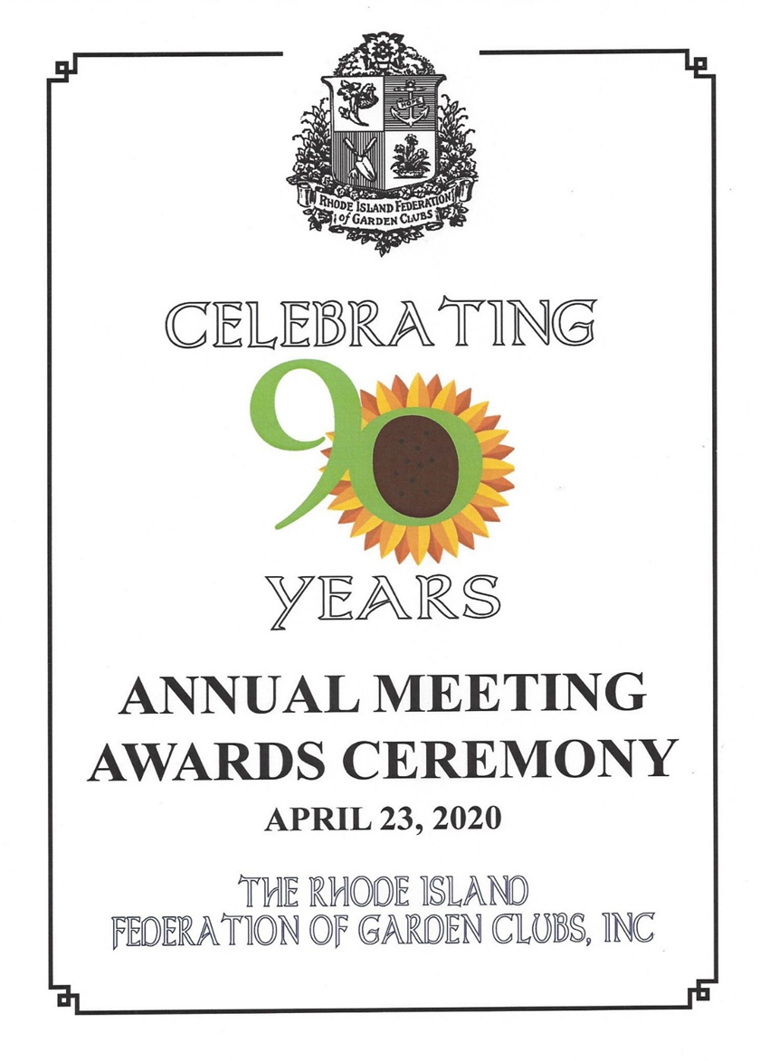

Please save the date and plan to join us for a very special day
as we begin our Annual Meeting and Awards ceremony with
an elaborate 90th Anniversary Luncheon. In the afternoon,
there will have an exciting surprise program
and an opportunity DRAWING.
It promises to be a day of good cheer, good food and good friend.

Location:
Agawam Hunt Club
15 Roger Williams Ave, Rumford, RI 02916
More details to follow.
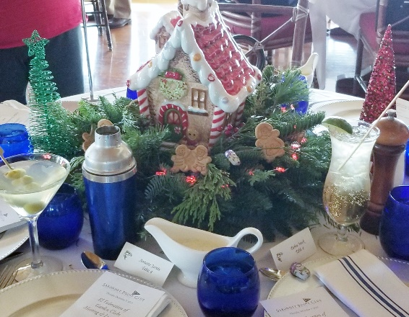
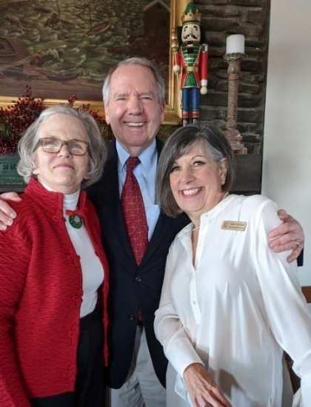
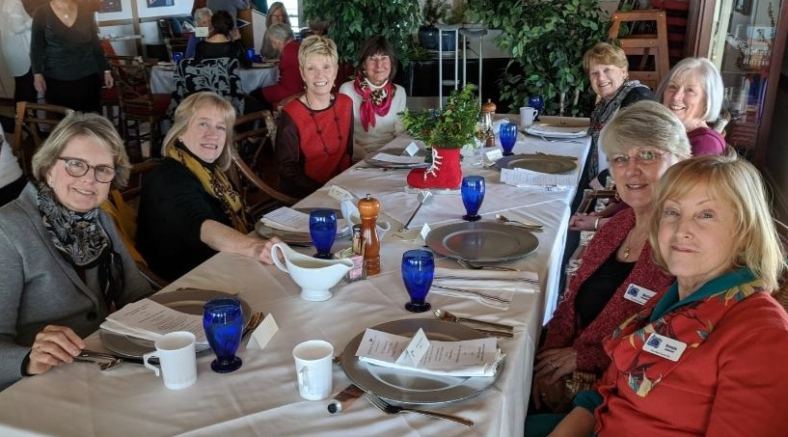
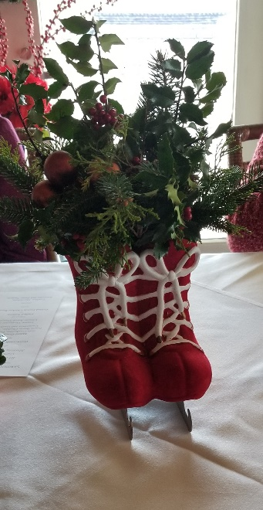
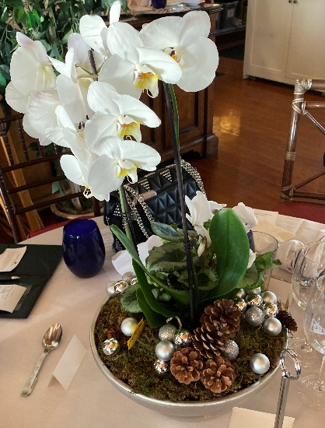
December 5, 2019
rifgc HOLIDAY LUNCHEON
SAKONNET POINT CLUB
Horticulture Specialty Flower Show

Information from the National Garden Club
HANDBOOK for FLOWER SHOWS, REVISED 2017

Condensed by Marj DeAngelis, Chair of Horticulture and Design Study

Six Basic Requirements
- Must contain a minimum of ten (10) horticulture classes (Specimens many be container-grown, cut, and/or combination plantings depending on section and/or class descriptions.)
- A minimum of forty (40) exhibits required
- May offer all NGC Top Exhibitor Horticulture Awards
- At least two (2) exhibits in any combination of Education, Garden and/or Youth must be included
- Botanical Arts, Botanical Arts Horticulture and/or photography may be included
- Eligible for the Horticulture Show Achievement Award
- No design exhibits permitted

Also, the same basic requirements of all NGC Flower Shows
- Must be planned and staged by NGC club members
- All fresh plant material
- Show schedule must be written and printed and include all specific working and essential details
- Judged by panel of NGC Judges
- The NGC Standard System of Awarding must be followed
- Exception in Horticulture, No design division

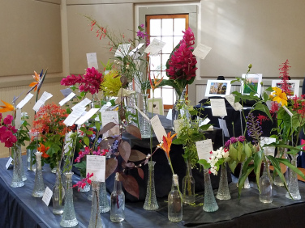
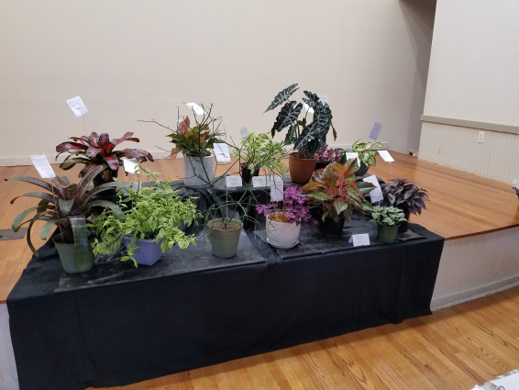

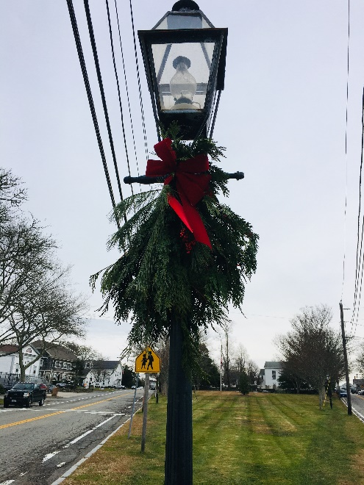

Sogkonate Garden Club Decorates
Little Compton Commons with
Annual Christmas Swags for lamp posts

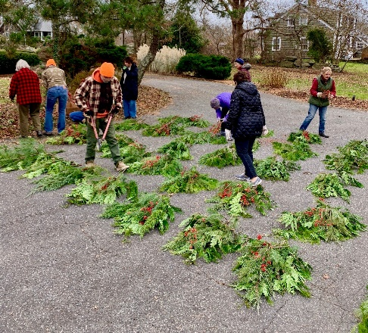
Sogkonate Garden Club members recently created 35 Christmas Swags which will be hung on the wrought iron lamp posts throughout Little Compton Commons. This annual event began 26 years ago in as a means for decorating the town for the annual Ben Wilkie Memorial Tree Spree held in the Wilbur McMahon Schools Gym. The assorted greens and berries were donated by SGC member Carolyn Faria and husband Gabe. Sandi Sparks who has been making the swags and hosting the event at her home for over 26 years, shares her special technique for creating the swags. The lush red velvet bows, which she makes herself, complete the swags, which must endure the strong winter winds of Little Compton. As part of the community event, the swags were hung by the personnel of the Little Compton Highway Dept.

Bristol Garden Club
“Rainkeep” a water collecting sculpture.

The Bristol Garden Club celebrated with the town the culmination of over years of effort in bringing the Rainkeep to Bristol. The water collecting sculpture is also an artistic rain barrel which will collect and provide water for Mrs. Perry's Garden at Thomas Park in Bristol. The functional sculpture is dedicated to "Our Children: Our Future," emphasizing the importance of utilizing opportunities for water conservation to deal with future environmental challenges. Through a host of fundraisers, grants, and private contributions, the Bristol Garden Club had raised $9,500 to finance the project.

We have now completed educational signage next to the Rainkeep. This project is slated for summer 2020.

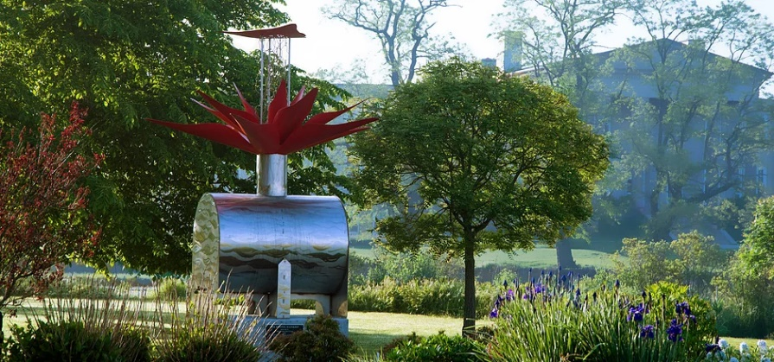
Its format is identical to that of other historical informational signage throughout the town. We are hoping to involve local children in the creation of environmentally themed steppingstones to lead visitors from the grassy areas to the sign.

Information sent by
Pam Bishop
Bristol Garden Club

The Quononoquott Garden Club’s Installation of the new Board was December 9, 2019. It was held at the Conanicut Yacht Club in Jamestown. A new slate of officers was sworn-in by Deborah Ort, the president of the Rhode Island Federation of Garden Clubs, Inc. They are a wonderful group of hardworking women. All board and club members were very friendly and so cheerful.

Picture above: Outgoing President Dianne Rugh, Deb Ort President RIFGC, new Co-President Denise Lazo, Treasurer Rose Natale, Secretary Pat DiPaolo, Co-Vice Presidents Molly Chamberlain and Kathy Bennett and Member at Large Natalie Haggerty.

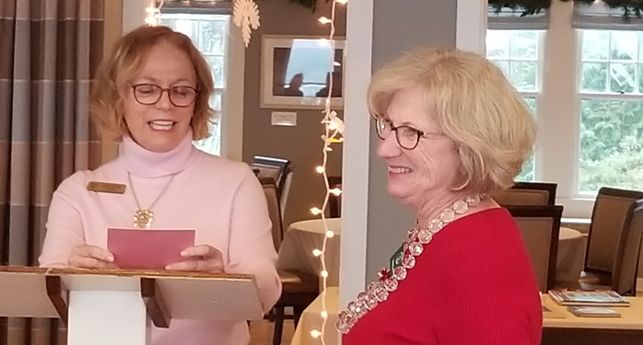

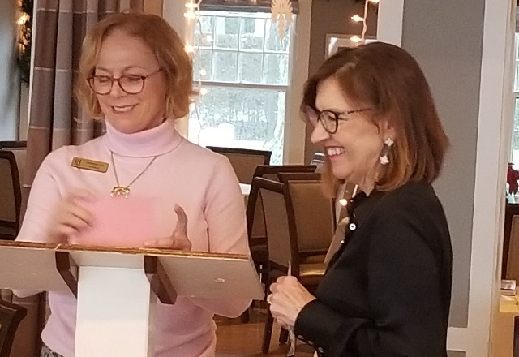
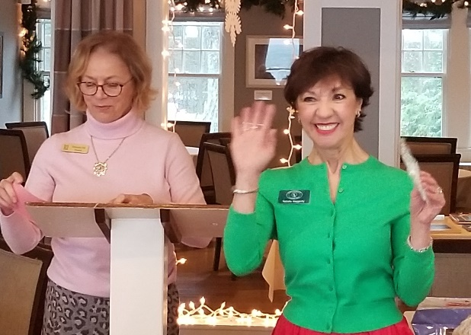

14,000 daffodils bulbs planted

For the past two decades the Quononoquott Garden Club members have continued to plant thousands of daffodils on Jamestown Island.

To date they have planted 14,000 daffodil bulbs.

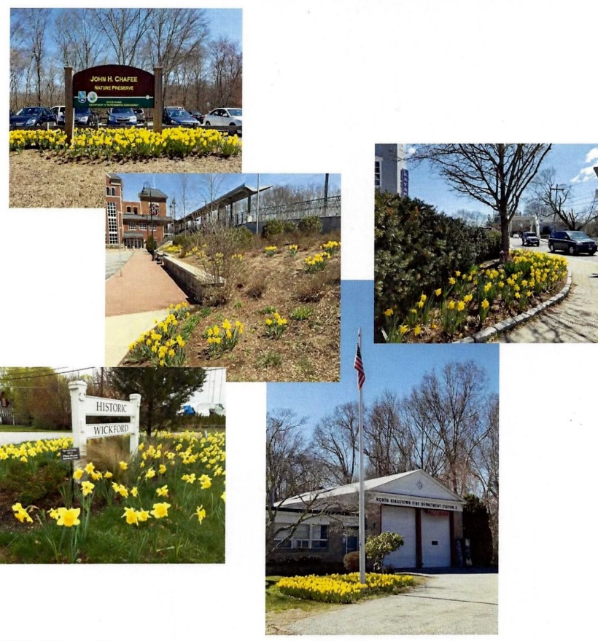
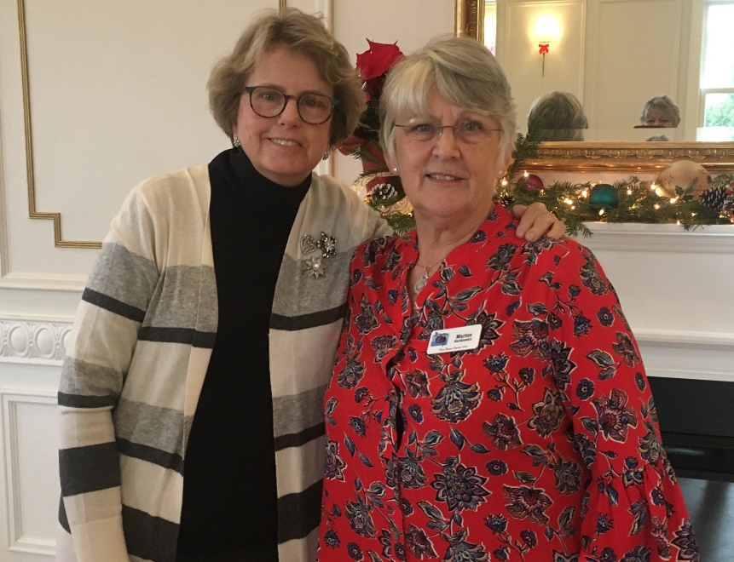
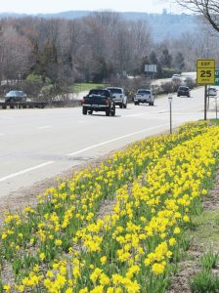
Kathleen Romeo, new President with Marion Bartkiewicz, past President

The new Board of the Plum Beach Garden Club was installed by President Deb Ort on December 10, 2019 at the Queen Anne's Loft 212 Thames Street, Newport.

The luncheon was delicious and the homemade desserts, made by club members were fabulous. Such a wonderful group of women!
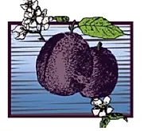

Plum Beach Garden Club

ESTABLISHED 1927

The following is an excerpt of the lecture presented by RI Tree Council’s Technical Advisor, John T Campanini, Jr at the RI Federation of Garden Clubs Annual Education Day Program- Roger Williams Park Casino, November 4, 2019. The lecture’s title was “Trending Pests and Weather Conditions Impacting Plants. Here is a list of “problem pests” that we all should be aware of.
PLANT PESTS- There are four plant pests that should be on the radar of all plant stewards in 2020. They are listed below:

1. Asian Long-horned Beetle (ALB- Anoplophora glabripennis)
2. Spotted Lanternfly (SLF- Lycorma delicatula)
3. Emerald Ash Borer (EAB- Agrilus plannipennis)
4. Bagworm (Thyridopteryx ephemeraeformis)
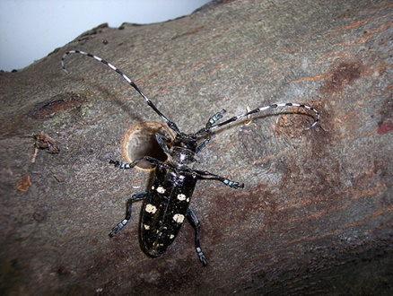
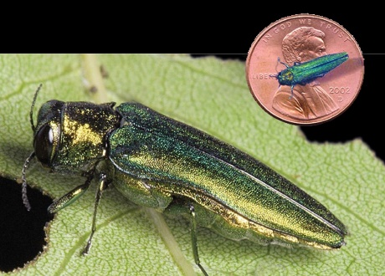
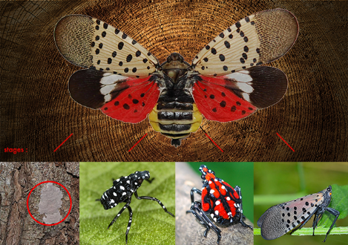
#1 #2 #3

Photo 1: The Asian Lon-horned Beetle adult is about ¾ to 1 ¼” long with
mottled spots on the back. Note the dime-sized exit hole made by adult
beetles as they emerge from the tree.
For more information about ALB, visit http://www.na.fs.fed.us/spfo/alb

Photo 2: EAB adult beetles are smaller than a penny.
They emerge in July to feed on ash leaves before laying their eggs
between layers of bark and in bark crevices. Learn about these options and more on EAB at www.emeraldashborer.info.

Photo 3: The important life stages of the Spotted Lanternfly: eggs, wingless nymphs and the adult
with wings for flight. To learn more on the SLF, visit: www.uri.edu/biocontrol/spotted-lanternfly

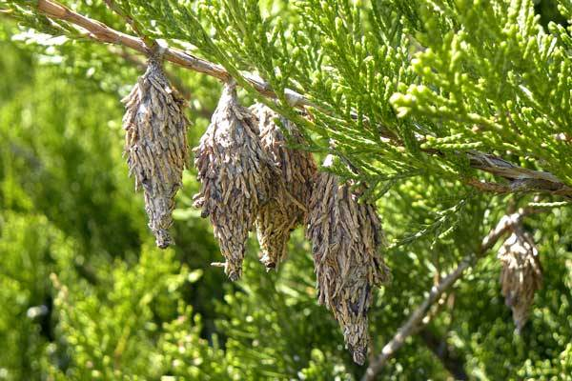
Photo 4: The tell-tale sign of bagworm infestation is the
dangling of inch long, oval-shaped bags from the
twigs of plants. For more bagworm details, visit www.info.psu.edu/extension/factsheets/bagworm

